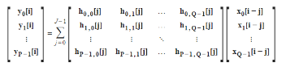
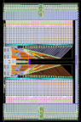
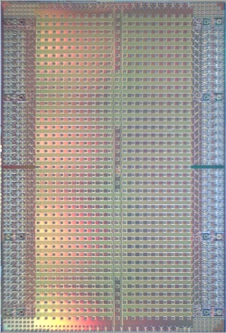

Job ID: 48997

Digital Design and DSP Internship (ASIC & DSP)

At Keysight we deliver hardware and software solutions for test-and-measurement in the fields of commercial communications, Automotive & Energy, General Electronics, Aerospace & Defense and Semiconductors. With more than 14,000 Keysight employees worldwide, we serve customers in more than 100 countries.

This internship is with the Keysight Laboratories ASIC Technology Team in Belgium. Keysight Laboratories is an international technology organization enabling Keysight to be first to market with breakthrough products and solutions.

ASICs and Digital Signal Processing (DSP) are the core business of this team and a key enabler for Keysight’s products.
We now have an opportunity for a Digital Design and DSP internship. This internship will provide you with the opportunity to extend your hands-on experience in DSP research and synthesized Digital and DSP design.
This position is based in Rotselaar, Belgium.
Job Description
- We are looking for an engineering intern in the field of Digital Design and DSP.
- You will work directly with Keysight Labs Engineers and contribute to actual research for Keysight’s future solutions.
- Example assignments you could engage in are:
  - Comparing hardware cost and performance for different algorithm implementations, doing RTL coding and synthesis experiments for state-of-the-art silicon technology nodes.
  - Building Matlab/Python models for algorithm performance analysis.
  - Comparing and investigating high speed Input/output protocols, Forward Error Correction and coming up with a recommendation of the state of the art, current and future standards, implementation complexity
  - Porting of ASIC VHDL/Verilog code to FPGA and vice versa
Expected Qualifications (or willingness to learn)
- You’re studying towards a degree in either Electronics and Chip Design, Information Systems and Signal Processing or Computer Sciences.
- You have a working knowledge in C++ or other object-oriented language.
- You are acquainted with Matlab, Python, …
- You have strong verbal and written communication skills in English.
- It’s a plus if
  - you have a working knowledge of Verilog/VHDL
  - you are familiar with the Linux operating system
  - you have a basic understanding of digital ASIC design methods and tools.

Contact: wim_cresens@keysight.com

Keysight Student Mentoring Program

The Student Mentoring Program is a short-form internship experience for you to get a taste of what life & work looks like working at Keysight, and to learn how your (future) student career fits in.
Throughout the month of July, we will be organizing a series of half-day gatherings at the Keysight offices in Rotselaar.

Topics and activities you can you expect during the Mentoring Program:

On-the-job Experiences and meeting Keysight people

- Use your engineering and team player skills during a hands-on mini-R&D project
- Meet our engineering colleagues and management live in Belgium and on-line in the USA

Tech presentations

- Get a taste of applied DSP theory and how our in-house ICs enable it in our instruments
- Learn the What? How? & Why? of IC design in Keysight Laboratories.

Demos

- Learn how a Test & Measurement instrument works
- See some of our state-of-the-art instruments in action

Career Guidance

- Get some examples of EE careers at Keysight
- Have your CV reviewed
- Do a (mock) job interview
- Get career guidance

Contact: wim_cresens@keysight.com

