R&D Software Engineer C++ internship position, Keysight Gent, Belgium
Keysight Technologies (NYSE: KEYS) helps its customers accelerate innovation to connect and secure the world. Keysight’s solutions optimize networks and bring electronic products to market faster and at a lower cost with offerings from design simulation, to prototype validation, to manufacturing test, to optimization in networks and cloud environments. Customers span the worldwide communications ecosystem, aerospace and defense, automotive, energy, semiconductor and general electronics end markets

As an intern, for a duration between 6 weeks and 3 months, you will be part of a fast growing R&D team located in Gent, Belgium that is responsible for the development of the commercial simulation tools used by PCB designers. These products provide CAD solutions for PCB hardware design engineers in their design and modeling work, covering Power Integrity (PI), thermal, Signal Integrity (SI) and EMI (Electromagnetic Interference) aspects. Within the Agile development team, you will have a chance to contribute to one or more development projects during the duration of the internship.

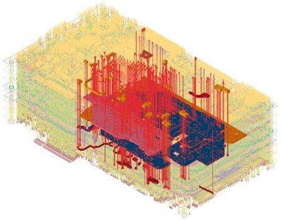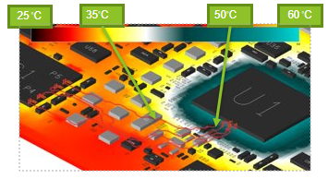

To be successful in this position, you bring with you:

- Experience in application programming using C++, Python
- Working towards master or Bachelor Degree in Software Engineering or Computer Science or Electrical Engineering
- Ability to work in a multi-site, multi-cultural team environment
- Good English writing/talking skills are required

How to apply
We are looking forward to your application through our website:
www.jobs.keysight.com

