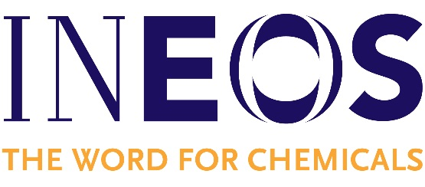

INEOS is one of the largest petrochemical companies in the world, employing around 19,000 people across 171 sites in 24 countries. With annual sales of $60bn, we have grown rapidly in the petrochemicals sector over the past 20 years, and have recently focused on broadening our activity into the Upstream sector. In many of the markets we operate in we are number one in the world.
We continue to grow and have recently announced a €2.7 billion investment in a new European chemical complex, the first new cracker to be built in Europe for 20 years. INEOS is also diversifying into some brand-new areas such as the automotive industry with Projekt Grenadier, the fashion industry with Belstaff and the sports world with the purchase of FC Lausanne.
Yet we are often referred to as the biggest company that you have never heard of, since we are not publicly quoted and don’t sell directly to consumers.
We are a unique, non-hierarchical organisation giving graduates direct access to senior management. If you thrive on a challenge and are prepared to push yourself, then INEOS’ open and direct approach to business will give you the opportunity to develop quickly, in a real job with real responsibilities from day one.
INEOS has well established graduate engineering programmes.
INEOS has 8 manufacturing sites in Belgium, 5 in the Antwerp region, with others in Feluy, Geel and Jemeppe. These manufacture products for 4 different INEOS businesses - Oxide, Olefins & Polymers, Inovyn and Styrolution.
There are a number of vacancies at these sites for a variety of engineering disciplines. Due to our decentralised structure, INEOS can provide careers for engineers who wish to remain located in Belgium within a particular business and we can also provide an international career in engineering and operations. Those who aspire to be future leaders are likely to be internationally mobile.
As an engineering graduate, you will be part of our Graduate Programme, which ensure you are developed and progressed, typically over a 5-year period.
To be considered for the scheme, you will need an engineering degree, as well as:
- The ability to work under pressure, with confidence
- A drive for action, initiative and delivery - a ‘can-do’ attitude
- Excellent communication skills
ARE YOU IN?
Send your résumé and covering letter to recruitment.belgium@ineos.com before November 20th.

