R&D Software Engineer Internship, Gent, Belgium

Keysight is on the forefront of technology innovation, delivering breakthroughs and trusted insights to the world’s visionaries and innovators in electronic design, test, manufacturing, and optimization. Our ~14,000 employees create world-class solutions in wireless communications, 5G, automotive, quantum, aerospace, defense, and semiconductor markets for customers in over 100 countries. Our technical solutions – and our methods for creating them – help connect and secure the world. Learn more about what we do and how we do it.
Our powerful culture has led to us being independently recognized on Fortune 100’s Best Companies List and we are “Great Place to Work” Certified. We’re driven, collaborative, ethical, and curious, and we value all ideas, especially bold ones. And our culture extends far beyond our own walls. Our corporate social responsibility efforts support our communities, nurture the next generation of engineers, and promote environmental sustainability.
At Keysight, Inclusion & Diversity is an integral part of our core values. We believe that when people feel a sense of belonging, they can be more creative, innovative, and thrive at all points in their careers. We believe everyone should be respected in the workplace and in their communities regardless of race, color, age, gender, sexual orientation, gender identity and expression, ethnicity, religion, disability, veteran status, national origin, or any protected class. We continuously challenge ourselves to grow in our understanding of inclusion by engaging in a wide variety of diversity programs, initiatives, employee network groups and mentoring/development. This is Keysight – People and Culture - YouTube
As an intern, for a duration from 6 weeks up to 3 months, you will be part of the R&D team located in Gent, Belgium that is responsible for the development of Electro-Magnetic (EM) simulation solutions for the RF, micro- and millimeter-wave product designers. Within the Agile development team, you will have the chance to contribute to one or more development projects aiming at providing solutions for PCB/Module/IC co-design.

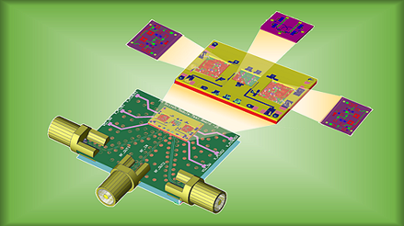

To be successful in this position, you bring with you:
- Experience in application programming using C++ and/or Python
- Working towards a Master or Bachelor Degree in Software Engineering, Computer Science or Electrical Engineering
- Ability to work in a multi-site, multi-cultural team environment
- Good English written and verbal communications skills are required

How to apply
We are looking forward to your application through our website: jobs.keysight.com

